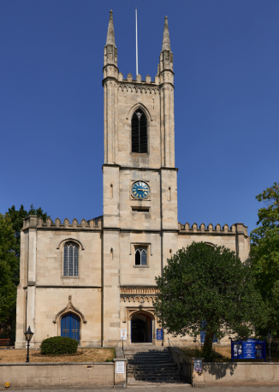
Windsor Parish Church
of
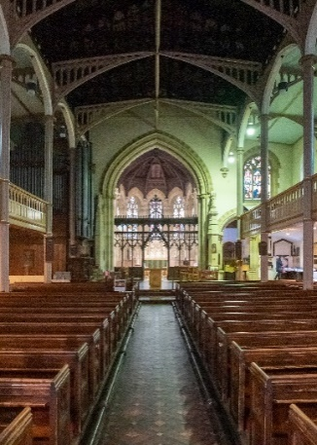
St John the Baptist

The “NEXT 200” Project

Help set the agenda for the next 200 years

The Parish Church of St John the Baptist occupies a prime town centre site where churches have stood since the twelfth century. The 200th anniversary of the current building was celebrated in 2022. A civic church for the Royal Borough of Windsor & Maidenhead, the church is open daily and is widely used by the church congregation, by community groups, schools and by many visitors, both local and from all over the world.

The Parochial Church Council has set up a committee to lead the restoration and development of the church and grounds, including representatives from the church congregation and more widely across the community. The recent Quinquennial survey lists what needs to be done in terms of addressing the immediate fabric defaults, but we have the opportunity within this project to take a broader, long-term view. We are privileged to have a prime, central Windsor location. We have a facility with wonderful acoustics and a high capacity to hold events for our community. We have the opportunity to create and develop a valuable space, fit for purpose for Christian worship, the wider local community and visitors alike.

Please help us shape this major project by answering the questions below.

1. Are you | A member of the congregation?
 | A visitor to the church
 | A member of a group/school/society which uses the church? If yes, then name your group/school/society.
2. What do you see as the current strengths of the building and grounds?

3. What do you see as the current weaknesses of the building and grounds?

4. What do you think would be the most important improvement?

5. What other improvements would you like to see?

6. Looking at the list below, please rate how important each would be to you. Please put a score between 1 to 10 where 1 is of low importance and 10 is of ultimate importance.

 | Accessible/Disabled Access
 | Car Parking
 | Roof and Other Stonework repairs
 | Creating more flexible space
 | Removable Pews
 | Raised Platform, Staging
 | Gallery seating with emergency exits
 | Toilets
 | Lighting
 | Heating
 | Bells
 | Additional Meeting Rooms
 | Kitchen
 | Cafe
 | Shop
 | Redecoration and tidy-up
 | Explanatory signs and literature
7. Have we missed anything? What other facilities would you like to have?

8. Any other comments?

If you are willing to be contacted about this project by Windsor Parish Church, please give your name and contact details:
NAME
EMAIL
Please return your questionnaire by either placing it in the box in the church entrance or email it to John Halsey at jphalsey@btinternet.com
If you would like more information, please email Michael Harding at mryh1@hotmail.com
WE WOULD BE GRATEFUL IF ALL QUESTIONNAIRES COULD BE COMPLETED AND RETURNED BY FRIDAY 14th MARCH 2025

THANK YOU FOR TAKING PART IN THIS – WE WILL KEEP YOU UPDATED AS THE PROJECT DEVELOPS

